Smart Monitor & Alert System

Project Handover Document

Author: Xiang, Yining (GDE-CLBP)
Last Updated: 8/26/2025

Table of Contents
- Project Overview
  - Project Name
  - Background
  - Key Concepts
- Stakeholders & Responsibilities
- Accounts and Docs
  - Central PC & Admin Account
  - Development Linux Server
  - File Transmission Notes
- Project Phases & Current Status
- System Design & Workflow
  - General Fridge Testing Process (①②③)
  - Monitoring App Workflow
  - Logic Description
  - Current Deliverables
- Next Steps
- Risks & Caveats
- Appendix / Reference Materials
  - GitHub Repo & Docs
  - Business Requirement Files
  - Config Files
  - Data Flow Graph
  - Web Demo
  - Frontend Wireframe

1. Project Overview
- Project Name: Smart Monitor and Alert System in Refrigerator Testing
- Background:
Currently, refrigerator testing relies on the sigmaDATA system to collect sensor data and generate performance curves. Engineers must manually analyze these curves to determine whether the refrigerator is functioning correctly.
This manual process presents two major challenges:
- High workload – Engineers must frequently check curves, which is repetitive and time-consuming.
- Risk of oversight – During busy periods, engineers may miss subtle bugs or anomalies due to limited time.
As a result, anomalies are not always detected immediately, leading to longer fault-to-detection cycles, wasted testing resources, and delayed feedback for software improvement.
To address this, the project aims to build an intelligent monitoring assistant that automatically receives testing data, detects anomalies in real time, and notifies engineers promptly.
- Key Concepts:
  - Sigmadata: The data acquisition system that collects refrigerator test data in real time. It connects to refrigerators under test, continuously collects real-time operational signals (e.g., compartment temperature, compressor power, fan status), and stores them.
  - Data Source: On central PC, sigmaData typically produces log files (.dat, .mpl, etc.), which contain raw sensor data in encoded binary format.
  - Anomaly: Some values appear to be abnormal, e.g.: temperature > 10 ℃.
  - Rule Engine: The logic that detects anomalies based on predefined conditions.
  - Alert: An alert (a.k.a notifier) will be sent to user’s phone/teams/email if an anomaly is detected.

2. Stakeholders & Responsibilities
Role | Name / Department | Responsibility
Department Head | Hauser Uwe (BSH GDE-CLB) <Uwe.Hauser@bshg.com> | Provides overall direction and sponsorship for the project; approves priorities and ensures alignment with department goals.
Team Head | You, Yilun (GDE-CLBP) <Yilun.You@bshg.com> | First point of contact for escalations; coordinates within the team; ensures resources and day-to-day management support.
Product Owner & Developer | Xiang, Yining (GDE-CLBP) < Yining.Xiang@bshg.com> | Responsible for end-to-end delivery: requirements clarification with users, product design, architecture design, development, testing, and coordinating cross-team resources. Acted as both PM and developer during initial phase.
Users | Wang, Baoyang (GDE-CLBVS1) <Baoyang.Wang@bshg.com>  Yang, Chen (GDE-CLBVSA1) <Chen.YangChe@bshg.com> | Future system users: provide requirements, validate business definitions, and review whether delivered features meet operational needs.
Central Server Account Manager | Xia, Yongshuai (GDE-CLBVL) <Yongshuai.Xia@bshg.com> | Manages central server access credentials, permissions, and account-related issues for the central server environment.
IT Support | Shi, Lei (GDS-ALPS) <Lei.ShiLei4@bshg.com> | Provides infrastructure support, including server configuration, deployment environment, and network connectivity.

3. Accounts and Docs
IP address:
- My PC: 10.67.225.123 (replace with your laptop’s ip address)
- Central PC: 10.88.40.140
Central PC Admin Account:
- Username: CZH\naa-sigmadata
- Password: (ask Xia, Yongshuai)
Linux server (for development):
- IP: 10.183.155.10
- Username: xuchuanji
- Password: (ask Xu, Chuanji)
- You should also ask him about the config file and initialize the virtual environment with conda. Do not close or restart any services. If there is a conflict, change your port number.
If you consider transmit data from the central pc to your pc/the Linux server, you can use the SFTP service.

4. Project Phases & Current Status
- Completed (Done)
  - Requirement clarification
  - Technical research
  - Prototype development (CLI & GUI & Web for demo)
  - Parse the encoded binary data (referencing SigmaData_DatParser.xlsx)
- In Progress
  - Develop the web frontend
  - Develop the real Rule Engine - Complete all rulesets referencing Rules.docx and the Parameter_file.xlsx
  - Internal testing
- To Do
  - Set up the data transmission pipeline from the central PC (server) to another server
  - Deployment and release
  - User training
  - Feedback collection and optimization

5. System Design & Workflow
Data Flow
Check Appendix 2
Data Flow (1) is the general testing process in all departments
Data Flow (2) and (3) are our design
General Fridge Testing Process (all departments have the same architecture)
① Raw Data Collected
  - Each refrigerator under test is connected to a UDA (Universal Data Acquisition) module.
  - The UDA collects raw operational signals such as temperature, power, and sensor readings.
② Data Sent to Central PC (aka central server)
  - All UDA devices send their collected data to a central PC (aka central server).
  - This central PC stores the data for further processing.
③ .dat Files Produced by Sigmadata
  - On the central PC, the Sigmadata software processes the incoming raw data.
  - Sigmadata generates .dat log files that contain structured test data and stores the log files under \\NAASWISIGMADB02\ED\Data (detailed path seen in SigmaData_DatParser.xlsx).
- These .dat files are later consumed by other tools (e.g., our anomaly monitoring application).

- Logic Description
  - Data acquisition from Sigmadata in real time
  - Rule engine checks for anomalies
  - Failure → real-time alert + log
  - Bug → log entry only
- Current Deliverables
  - Demo scripts
  - Service framework
  - Example anomaly logs

6. Next Steps
- Technical
  - Expand rule library
  - Improve log analysis & visualization
  - Production deployment
- Organizational
  - Train engineers on system usage
  - Establish anomaly handling workflow

7. Risks & Caveats
- Data Interface: Sigmadata does not provide an API; only TCP-based access is available.
- Network Environment: Alerts/notifications may be limited by intranet/extranet restrictions.
- System Maintenance: Logs and data storage require ongoing management.

8. Appendix / Reference Materials
- Technical documentation (code directory, key script descriptions)
- Demo usage guide
- Contact list

Appendix 1
GitHub:
XYI8NJ/Smart_Monitor_Dev (Remember to read README.md and all files under `docs/` The account might be closed.)

Business Requirement:
Rules.docx (provided by our users, two test engineers Wang, Baoyang (GDE-CLBVS1) & Yang, Chen (GDE-CLBVSA1))
Check `docs/` for the following xlsx files. For more information, read README.md:
labels.xlsx
Parameter_file.xlsx
SigmaData_DatParser.xlsx
Check `config/` for the following xlsx files. For more information, read README.md:
label_channel_match.yaml
rules.yaml

Appendix 2
Data Flow Graph: How Data Flow
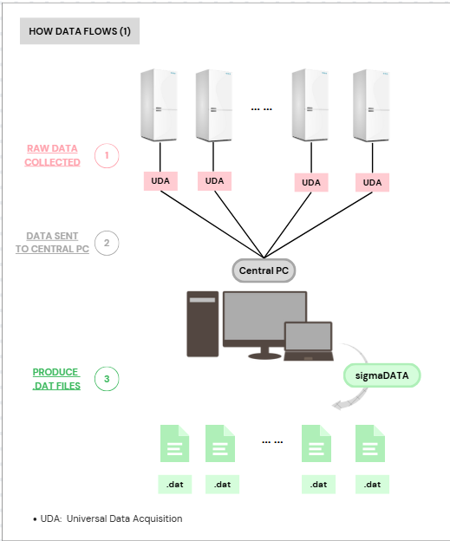
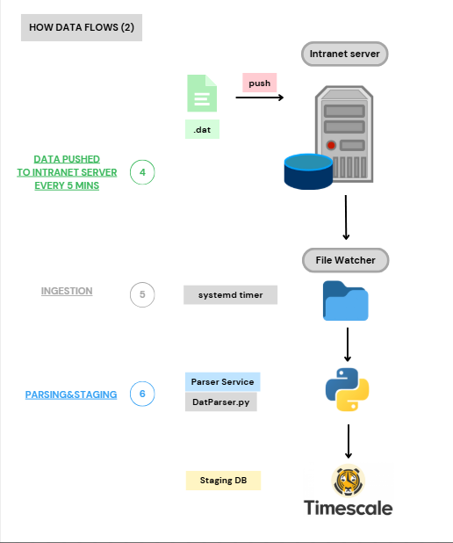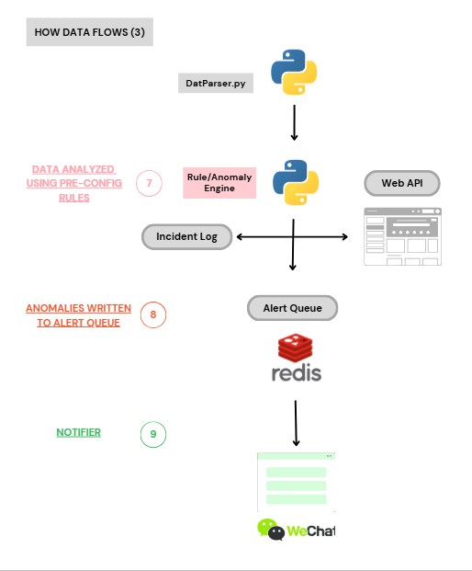

Appendix 3
Web Demo:
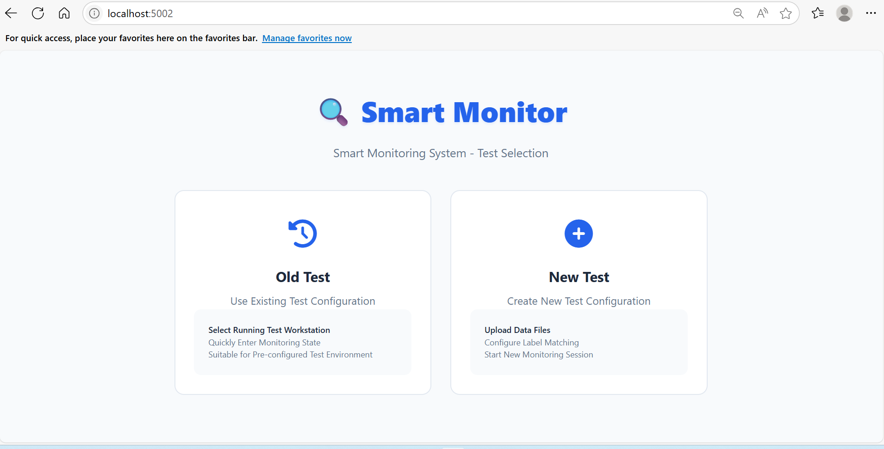
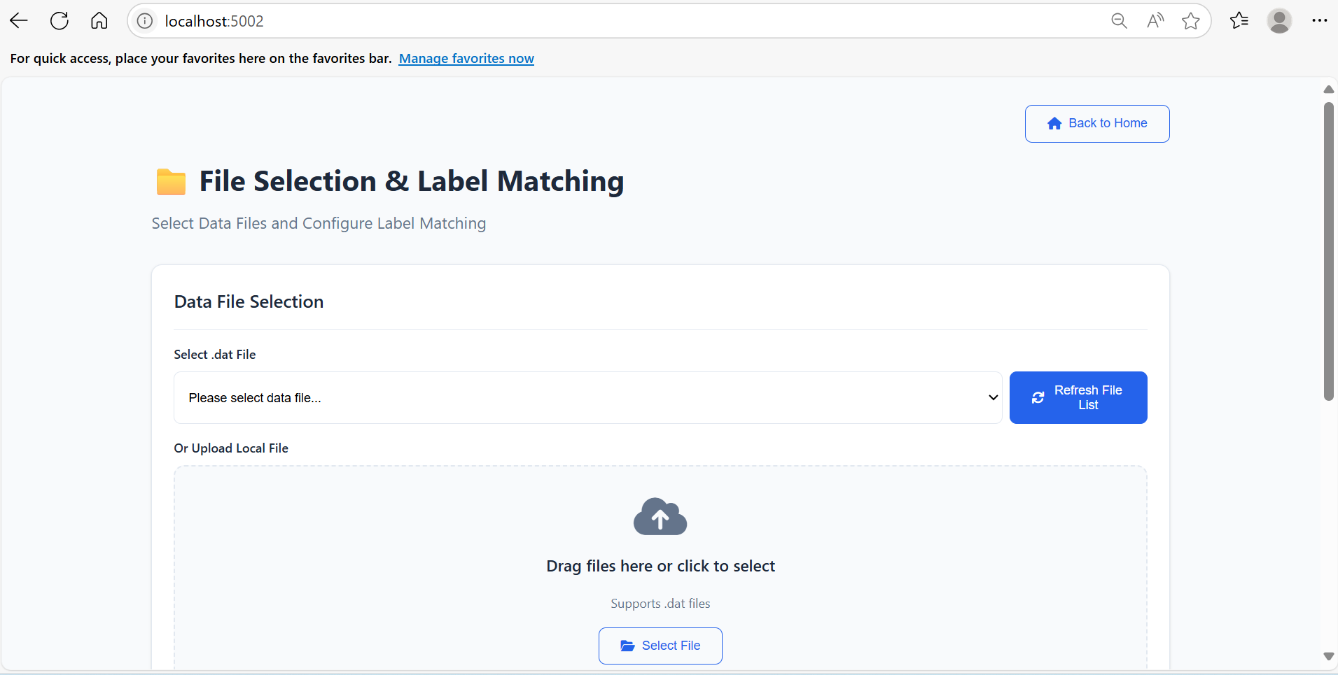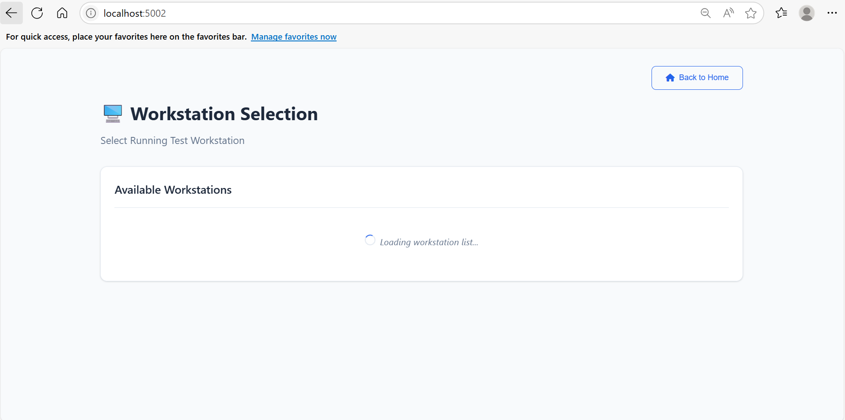
Appendix 4
Frontend Design (Wireframe): Smart Monitor Design – Figma
